Periodic motion: A motion that repeats itself after equal intervals of time is known as periodic motion.
Examples of periodic motion: a tuning fork or motion of a pendulum if you analyze the motion you will find that the pendulum passes through the mean position only after a definite interval of time.
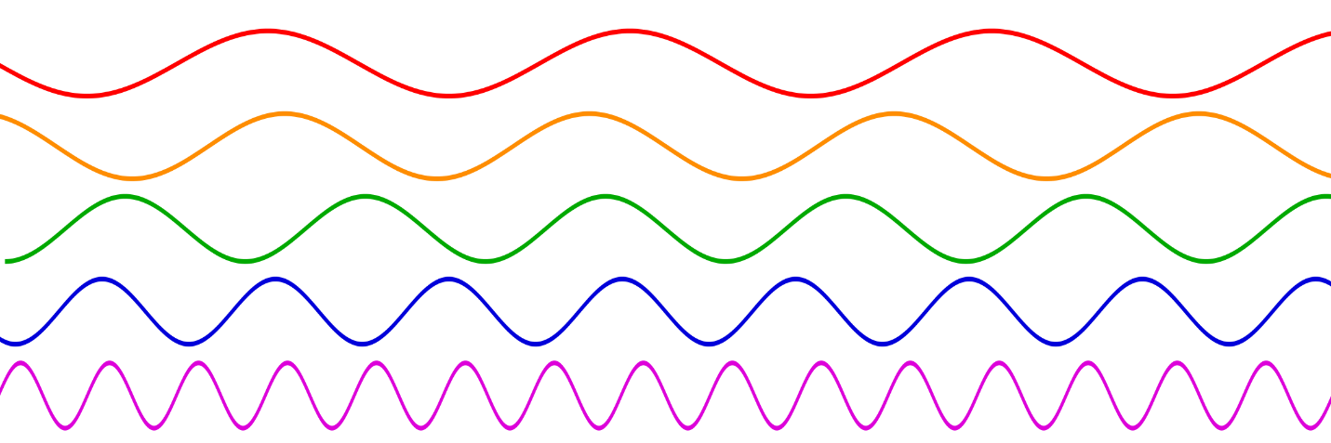

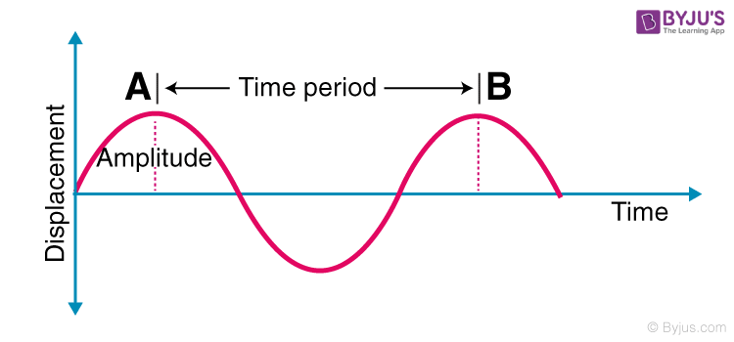
Time Period (T): It is the time taken by the motion to repeat itself. So the unit of a time period is seconds.
Frequency (f): It is defined as a number of times the motion is repeated in one second. The unit of frequency is Hz (Hertz). Frequency is related to Time period as:
$$T=\frac{N}{f}$$
Understanding the Restoring Force
Newton’s first law implies that an object oscillating back and forth is experiencing forces. Without force, the object would move in a straight line at a constant speed rather than oscillate. It is important to understand how the force on the object depends on the object’s position. If an object is vibrating to the right and left, then it must have a leftward force on it when it is on the right side, and a rightward force when it is on the left side. In one dimension, we can represent the direction of the force using a positive or negative sign, and since the force changes from positive to negative there must be a point in the middle where the force is zero. This is the equilibrium point, where the object would stay at rest if it was released at rest. It is common convention to define the origin of our coordinate system so that x equals zero at equilibrium.
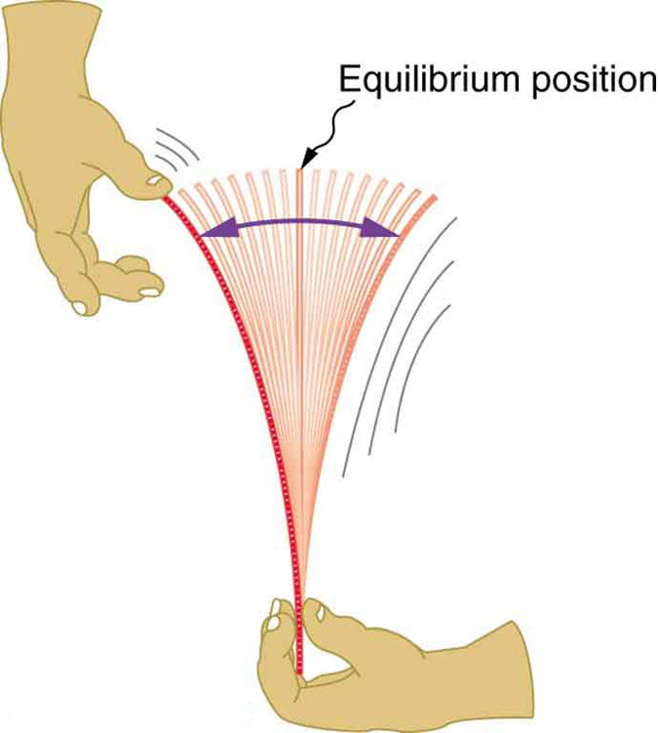
Simple Harmonic motion: A special type of periodic motion where an object's acceleration is directly proportional to its displacement from a central equilibrium position and is always directed towards that position.
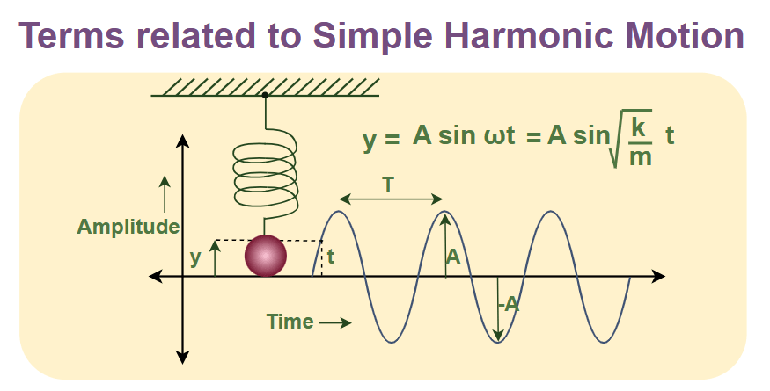
Hook’s Law: The foundation for simple harmonic motion, where the restoring force is directly proportional to the displacement from equilibrium and acts in the opposite direction.  $$F=-kx$$  Where k is spring constant defined as the amount of force need to stretch or compress its by a unit of distance.  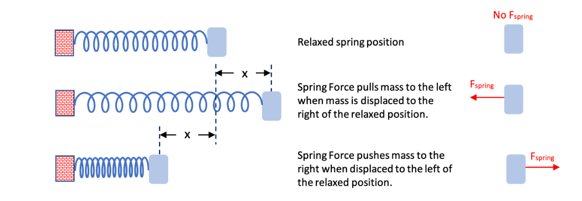 | Characteristics of SHM  - Restoring force is proportional to displacement.  - Motion is periodic and repeats over time.  - Acceleration is directed toward equilibrium.  - Displacement follows a sinusoidal pattern.  - Total mechanical energy remains constant.

#Derive 2nd order Differential equation of SHM  Consider a particle of mass (m) executing Simple Harmonic Motion along a path x o x; the mean position at O. Let the speed of the particle be v₀ when it is at position p (at a distance no from O).  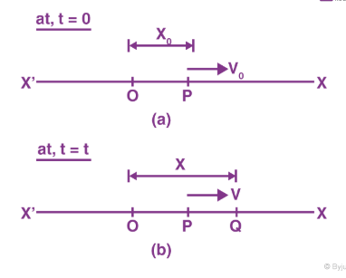  The restoring force F at Q is given by,  $$F=-Kx$$  Where k is a positive constant. Also F=ma,  $$ma=-Kx$$  $$m\frac{∂^{2}x}{∂x^{2}}=-kx$$  $$\frac{∂^{2}x}{∂t^{2}}+\frac{k}{m}x=0$$  $$\frac{∂^{2}x}{∂t^{2}}+ω^{2}x=0$$  This is the 2nd order differential equation for linear Simple Harmonic Motion. Where $ω^{2}=\frac{k}{m}$ is angular frequency.  #Kinetic Energy in SHM  Consider a particle of mass mm oscillating with simple harmonic motion about its equilibrium position.  $$E_{K}=\frac{1}{2}mV^{2}$$  Since  $V=AωCos\left(ωt+δ\right)$ and $ω^{2}=\frac{k}{m}$, $ω^{2}m=k$  $$E_{K}=\frac{1}{2}m{[AωCos\left(ωt+δ\right)]}^{2}$$  $$E_{K}=\frac{1}{2}mω^{2}A^{2}Cos^{2}\left(ωt+δ\right)$$  $$E_{K}=\frac{1}{2}KA^{2}Cos^{2}\left(ωt+δ\right)$$ | #Solution of Differential Equation For SHM  $$Displacement↔X=A Sin(ωt+δ)$$  Where (ωt + Φ) is the phase of the particle, the phase angle at time t = 0 is known as the initial phase.  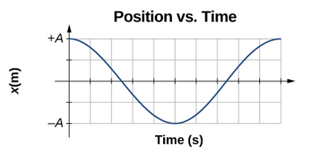  #Velocity in SHM:  $$V=\frac{dx}{dt}=\frac{d}{dt}A Sin\left(ωt+δ\right)=AωCos\left(ωt+δ\right)$$  $$V=Aω\sqrt{1-Sin^{2}\left(ωt+δ\right)}$$  $$V=ω\sqrt{A^{2}-A^{2}Sin^{2}\left(ωt+δ\right)}$$  $$V=ω\sqrt{A^{2}-{\left(ASin\left(ωt+δ\right)\right)}^{2}}$$  $$V=ω\sqrt{A^{2}-x^{2}}$$  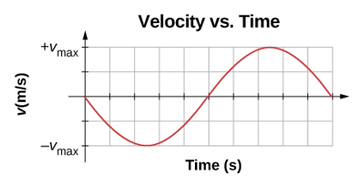  #Acceleration in SHM  $$a=\frac{dv}{dt}=AωCos\left(ωt+δ\right)=-ω^{2}ASin\left(ωt+δ\right)$$  $$a=-ω^{2}X$$  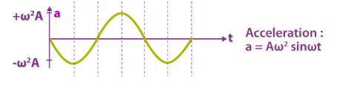
# Potential Energy in SHM  The total work done by the restoring force in displacing the particle from(x=o) (mean position) to x=x.  When the particle has been displaced from x to x+dx, the work done by restoring force is  $$dW=Fdx=-kx$$  $$W=\int{dw}=\int_{0}^{x}{-kxdx}=-\frac{1}{2}Kx^{2}$$  Since $ω^{2}m=k$  $$W=-\frac{1}{2}{ω^{2}mx}^{2}=-\frac{1}{2}{ω^{2}mA}^{2}Sin^{2}(ωt+δ)$$  Potential energy=-(Work done by restoring force)  $$E_{P}=\frac{1}{2}{ω^{2}mA}^{2}Sin^{2}(ωt+δ)$$  $$E_{P}=\frac{1}{2}{KA}^{2}Sin^{2}(ωt+δ)$$ | 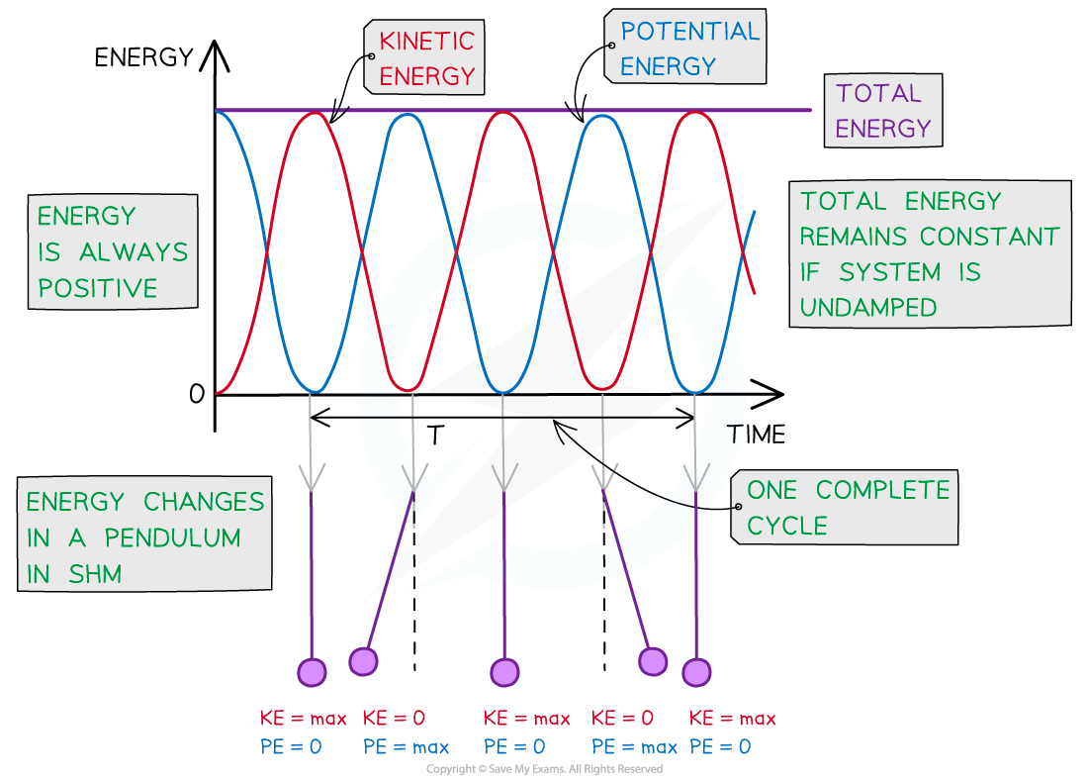
# Show that total energy of the particle executing SHM is directly proportional to the square of its amplitude
$$E=E_{K}+E_{P}=\frac{1}{2}KA^{2}Cos^{2}\left(ωt+δ\right)+E_{P}=\frac{1}{2}{KA}^{2}Sin^{2}\left(ωt+δ\right)$$
$$E=\frac{1}{2}KA^{2}$$
$E∝A^{2}$ (Showed)

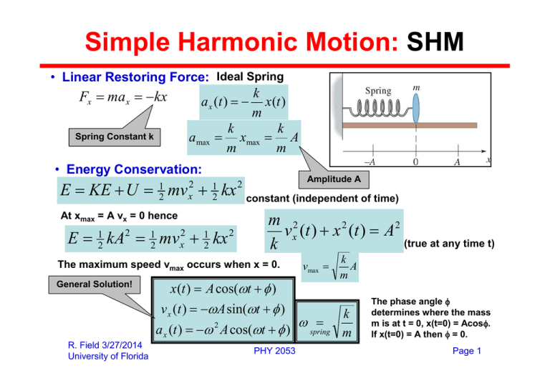
Problem-1: A 2-kg block is attached to a spring whose constant is 32 N/m horizontally. Imagine it being displaced from equilibrium by 4 cm and released from rest. How much time does it take for the block to reach the point x=2 cm?
Solution: We know that a mass attached to a spring undergoes a simple harmonic motion (SHM) with the equation x=ACosωt
The block's period of oscillation is found by,
$$T=2π\sqrt{\frac{m}{K}}$$
$$T=2π\sqrt{\frac{2}{32}}$$
$$T=\frac{π}{4}sec$$

Therefore, the angular frequency is,
ω=2π/T=8rad/s
In this example, the maximum distance (amplitude) from where the block is released at time
t=0 is 4 cm, so A=0.4m.
Substituting these quantities into the above equation of SHM, x=0.4mCos(8t)
This equation gives the location of the object at any instant of time.
If we put x=0.2m into the equation above and solve for the time t, it gives the time required to reach that point.
x=0.4Cos(8t)
0.2=0.4Cos(8t)
⇒1/2=Cos(8t)
t=π/48=0.06s
Hence, it takes 0.06 seconds for the object to reach the point located at x=2 cm.

Problem 2: An object of 45 N is hanging from a spring vertically. The spring is stretched from its equilibrium point by 0.14 m. What is the spring constant?
Solution: The spring is initially unloaded and unstretched. Hanging a 45-N object from it causes it to stretch by 0.14 m. This system is at rest and, therefore, at equilibrium. Applying Newton's second law gives the following formula to find the spring stiffness constant

$$k=\frac{mg}{x}=\frac{45}{0.14}=321.4Nm^{-1}$$

Note that x​ is the length the unloaded spring is initially stretched by an object's weight.

